
• GIA PRESS • 2026
  JOURNAL IDENTITY  Journal of Action Research in Education  GIA Press | jarse.giapress.com  PUBLICATION METADATA  Volume: [XX] Issue: [X]  DOI: [add assigned article DOI]  Received: [day month year]  Revised: [day month year]  Accepted: [day month year]  ARTICLE CATEGORY  ☐ Classroom Action Research  ☐ Participatory Educational Action Research  ☐ Practitioner Inquiry with documented iterative improvement  ☐ Methodological Reflection grounded in complete action-research evidence.  REPORTING PRIORITY  Show the initial teaching problem, iterative actions, evidence gathered in each cycle and revisions based on reflection.  EDITORIAL NOTE  Replace bracketed fields and all instructions before submitting. Journal identifiers are placeholders until verified. | MANUSCRIPT TITLE  [Insert a precise, searchable article title identifying the study, intervention and context]  Article type: [select a category from the journal list]  ABSTRACT  Write a self-contained abstract of 150–250 words. Initial classroom difficulty; action objective; setting/participants; cycles and instruments; results across cycles; reflection and applicability.  KEYWORDS  [keyword 1]; [keyword 2]; [keyword 3]; [keyword 4]; [keyword 5]  SCOPE AND CONTRIBUTION  Demonstrate how planned educational action and systematic observation changed practice over documented cycle(s).  FORMATTING AT A GLANCE  • Language: English; editable Word manuscript (.docx).  • Suggested length: approximately 4,000–7,000 words; APA 7 references.  • Title and manuscript must describe what was actually investigated or implemented.

1. Introduction and Baseline Diagnosis
Describe the classroom or educational practice problem using baseline observations or assessment. Establish its significance, define the intended improvement and explain why iterative educational action is appropriate.
Demonstrate how planned educational action and systematic observation changed practice over documented cycle(s).
WHAT BELONGS HERE State the action, instructional problem and educational context; avoid vague 'efforts to improve' titles.

2. Action Research Method
Describe the action-research cycles in a manner that allows readers to trace each decision from diagnosis through planning, action, observation and reflection. State what was modified between cycles and why.
Participants/setting; baseline diagnosis; action planning; implementation; observation instruments; reflection criteria; changes and rationale between cycles.

Designs appropriate to this journal
Classroom action research, participatory action research, collaborative practitioner inquiry or another justified iterative action-research design.

Minimum methodological documentation
- Problem diagnosis and clear success indicators
- Plan, act, observe and reflect procedures for each cycle
- Instruments, data collection and reasons for revising the next cycle

3. Findings by Cycle
Present evidence for each cycle, compare with baseline and explain what changed after reflection. Do not interpret descriptive fluctuations as causal proof without justification.
EVIDENCE STANDARD Baseline classroom problem, planned action, observed evidence, reflection and iterative modification, documented change and cautious interpretation.

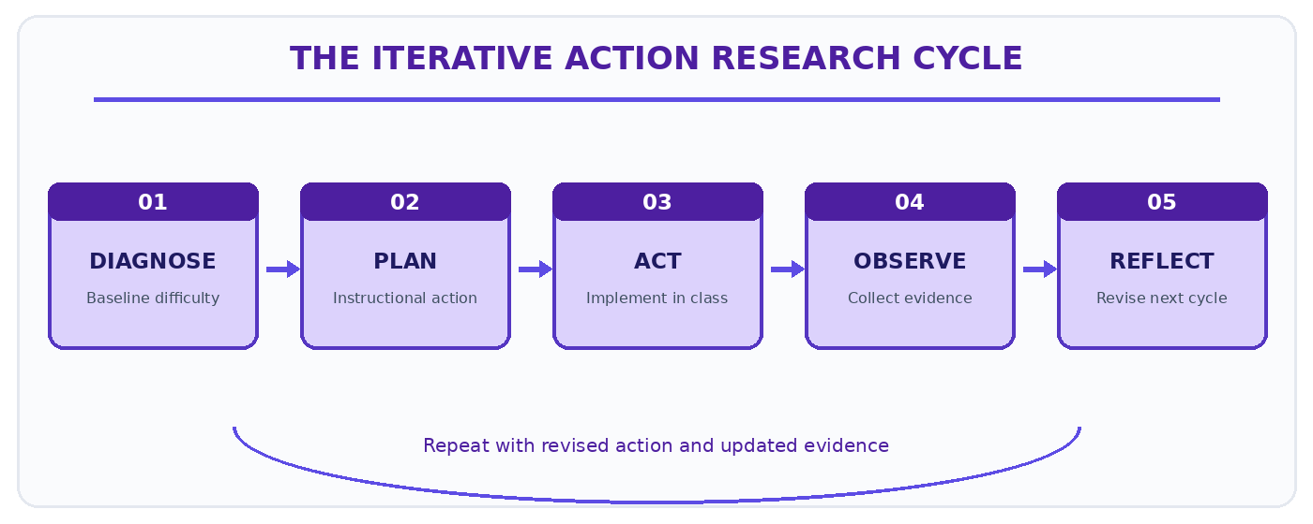
Figure 1. Illustrative reporting pathway for JARSE manuscripts. Replace with a study-specific figure.

4. Cross-Cycle Discussion and Reflection
Link each instructional modification to the observed learning or practice evidence, alternative explanations and transfer conditions.
Explain how the results answer the stated problem, compare with relevant literature and account for alternative explanations or limitations. Interpret evidence without extending conclusions beyond the observed data.

5. Conclusion
Conclude by directly answering the study objective and describing its contribution, limits and implications. Avoid broad claims not supported by the study.
State the observed improvement relative to the diagnosed problem and explain which revisions across the action cycle appear important. Do not assert causality from isolated score changes.

6. Figures, Tables and Statistical Reporting
Number figures and tables consecutively as cited in the manuscript. Place figure captions below figures and table titles above tables. Supply legible labels, units, definitions, and data provenance. Do not fabricate or cosmetically manipulate findings.
Table 1. Example of a journal-specific evidence summary (replace with actual data).
Learning indicator | Baseline | Cycle 1 / Cycle 2 | Observation / reflection
[Insert verified data] | [Insert verified data] | [Insert verified data] | [Insert verified data]
[Insert verified data] | [Insert verified data] | [Insert verified data] | [Insert verified data]
[Insert verified data] | [Insert verified data] | [Insert verified data] | [Insert verified data]
Table note. Replace this demonstration with measurements or observations from the submitted study; explain denominators, missing values and interpretation where applicable.

Reference and citation conventions
APA 7; reference relevant action-research methodology, curriculum/assessment research and the particular learning problem.
SUBMISSION CHECK Use the correct article type and section order. Put figures and tables near first mention, and retain editable text in the Word file.

7. Declarations and Ethical Reporting
State school permissions and ethics arrangements, protect pupil identities, distinguish teacher/researcher dual roles and keep cycle data auditable.
Ethics approval: [Name of committee or a reason approval was not applicable; approval number if granted.]
Consent and permissions: [How informed consent and applicable institutional or partner permissions were obtained.]
Funding: [Funder and grant number, or a declaration that no external funding was received.]
Competing interests: [Disclose any competing interests, or state that none are declared.]
Author contributions: [Specify substantive contributions of each author, consistent with journal policy.]
Data and materials availability: [Repository or access conditions; state any ethical, legal or contractual restrictions.]
AI assistance disclosure: [Disclose relevant generative AI assistance and verify all manuscript claims, data and sources.]

8. References
Prepare the reference list in APA 7 format. Every in-text citation must have a matching reference, and each reference must be cited in the text. Do not include fabricated references or unverifiable DOI links.
[Insert references here using a reference manager and validate bibliographic details.]

9. Author Information (Final Accepted Version Only)
[Author name] | [Department and institution, country] | ORCID: [verified ID] | Email: [address]. Remove this information from review copies when anonymous review is required.

10. Pre-Submission Checklist
- The study or completed programme is within this journal’s scope and the article type is accurate.
- The abstract is 150–250 words; the manuscript contains 3–5 precise keywords.
- The methods and results meet the journal-specific evidence standard.
- The figures, tables, citations and references are complete and technically legible.
- Permissions, ethics, funding, contributions, data access and relevant AI disclosures are reported.

