
• GIA PRESS • 2026
  JOURNAL IDENTITY  Journal of Science Research and Education  GIA Press | jsre.giapress.com  PUBLICATION METADATA  Volume: [XX] Issue: [X]  DOI: [add assigned article DOI]  Received: [day month year]  Revised: [day month year]  Accepted: [day month year]  ARTICLE CATEGORY  ☐ Original Research Article  ☐ Systematic Review (with reproducible search methods)  ☐ Methodological/Instrument Study  ☐ Research-based Short Communication (only with sufficient evidence).  REPORTING PRIORITY  Report an answerable scientific or science-education question with replicable methods and verifiable findings.  EDITORIAL NOTE  Replace bracketed fields and all instructions before submitting. Journal identifiers are placeholders until verified. | MANUSCRIPT TITLE  [Insert a precise, searchable article title identifying the study, intervention and context]  Article type: [select a category from the journal list]  ABSTRACT  Write a self-contained abstract of 150–250 words. Problem/gap; objective; design, sample or material and analysis; leading findings (with numerical details where relevant); conclusion and field relevance.  KEYWORDS  [keyword 1]; [keyword 2]; [keyword 3]; [keyword 4]; [keyword 5]  SCOPE AND CONTRIBUTION  Address an identifiable gap in scientific or science-education knowledge using defensible research methods.  FORMATTING AT A GLANCE  • Language: English; editable Word manuscript (.docx).  • Suggested length: approximately 4,000–7,000 words; APA 7 references.  • Title and manuscript must describe what was actually investigated or implemented.

1. Introduction
State the scientific phenomenon or science-learning issue, assess relevant previous findings and identify the precise gap the study addresses. End with an answerable question or explicit research objective.
Address an identifiable gap in scientific or science-education knowledge using defensible research methods.
WHAT BELONGS HERE Specific and searchable; identify scientific phenomenon or learning issue, main approach and relevant context, avoiding promotional claims.

2. Methods
Specify the scientific or educational research design and the procedures needed to reproduce the data collection and analysis. Explain controls, measurement quality and appropriate handling of uncertainty.
Research design; settings or materials; instruments/calibration; sample and selection; measures; analysis; controls/validity where applicable.

Designs appropriate to this journal
Experimental, quasi-experimental, observational, modelling, laboratory, survey with sound analysis, instrument-validation and reproducible reviews.

Minimum methodological documentation
- Population or materials, sampling, measurement and controls
- Calibration, instruments, analytical methods and uncertainty
- Justification for the design, validity and reproducibility

3. Results
Tables/figures and exact findings matching research questions; appropriate uncertainty; do not replace results with illustrative screenshots.
EVIDENCE STANDARD Explicit research question, justified method, credible data, defensible analysis, limitations and reproducible reporting.

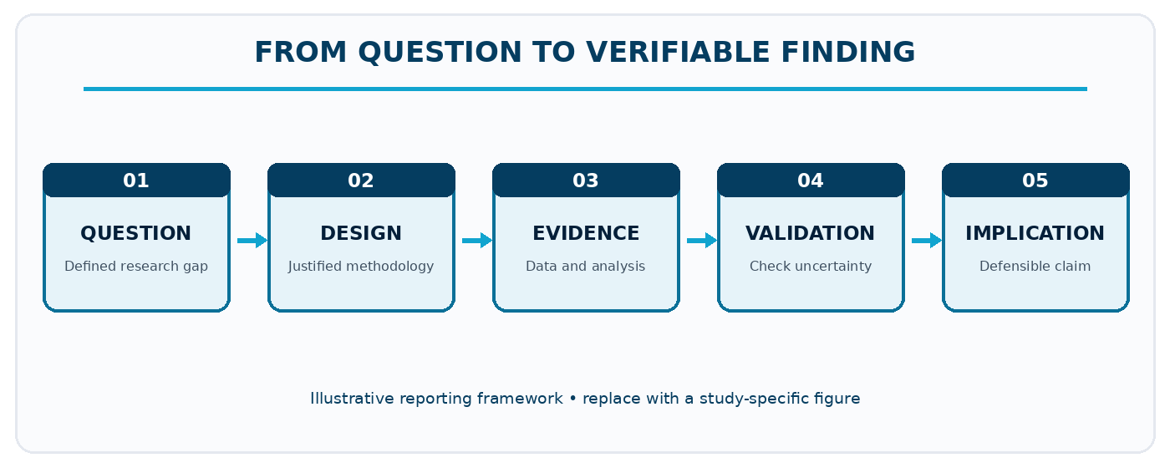
Figure 1. Illustrative reporting pathway for JSRE manuscripts. Replace with a study-specific figure.

4. Discussion
Compare major results against up-to-date international literature; discuss mechanisms, uncertainties, limits and implications.
Explain how the results answer the stated problem, compare with relevant literature and account for alternative explanations or limitations. Interpret evidence without extending conclusions beyond the observed data.

5. Conclusion
Conclude by directly answering the study objective and describing its contribution, limits and implications. Avoid broad claims not supported by the study.
Specify what is supported by data, the main uncertainties, and where the findings apply or require further verification.

6. Figures, Tables and Statistical Reporting
Number figures and tables consecutively as cited in the manuscript. Place figure captions below figures and table titles above tables. Supply legible labels, units, definitions, and data provenance. Do not fabricate or cosmetically manipulate findings.
Table 1. Example of a journal-specific evidence summary (replace with actual data).
Variable / measure | Comparator | Finding [unit] | Verification / analysis
[Insert verified data] | [Insert verified data] | [Insert verified data] | [Insert verified data]
[Insert verified data] | [Insert verified data] | [Insert verified data] | [Insert verified data]
[Insert verified data] | [Insert verified data] | [Insert verified data] | [Insert verified data]
Table note. Replace this demonstration with measurements or observations from the submitted study; explain denominators, missing values and interpretation where applicable.

Reference and citation conventions
APA 7; sources appropriate to research design and disciplinary knowledge; prioritise recent primary research without arbitrary omission of foundational works.
SUBMISSION CHECK Use the correct article type and section order. Put figures and tables near first mention, and retain editable text in the Word file.

7. Declarations and Ethical Reporting
Declare consent/ethics clearance where applicable, funding, individual author contributions, conflicts and data availability; retain research records.
Ethics approval: [Name of committee or a reason approval was not applicable; approval number if granted.]
Consent and permissions: [How informed consent and applicable institutional or partner permissions were obtained.]
Funding: [Funder and grant number, or a declaration that no external funding was received.]
Competing interests: [Disclose any competing interests, or state that none are declared.]
Author contributions: [Specify substantive contributions of each author, consistent with journal policy.]
Data and materials availability: [Repository or access conditions; state any ethical, legal or contractual restrictions.]
AI assistance disclosure: [Disclose relevant generative AI assistance and verify all manuscript claims, data and sources.]

8. References
Prepare the reference list in APA 7 format. Every in-text citation must have a matching reference, and each reference must be cited in the text. Do not include fabricated references or unverifiable DOI links.
[Insert references here using a reference manager and validate bibliographic details.]

9. Author Information (Final Accepted Version Only)
[Author name] | [Department and institution, country] | ORCID: [verified ID] | Email: [address]. Remove this information from review copies when anonymous review is required.

10. Pre-Submission Checklist
- The study or completed programme is within this journal’s scope and the article type is accurate.
- The abstract is 150–250 words; the manuscript contains 3–5 precise keywords.
- The methods and results meet the journal-specific evidence standard.
- The figures, tables, citations and references are complete and technically legible.
- Permissions, ethics, funding, contributions, data access and relevant AI disclosures are reported.

