
• GIA PRESS • 2026
  JOURNAL IDENTITY  Journal of Community Services in Society  GIA Press | jocsis.giapress.com  PUBLICATION METADATA  Volume: [XX] Issue: [X]  DOI: [add assigned article DOI]  Received: [day month year]  Revised: [day month year]  Accepted: [day month year]  ARTICLE CATEGORY  ☐ Community Engagement Article  ☐ Participatory Intervention Report  ☐ Evidence-Based Programme Evaluation  ☐ Community Innovation and Technology Transfer Report. Literature-only research is not accepted as a substitute for implemented service.  REPORTING PRIORITY  Describe a completed programme, a documented community need, participating partners and evidence of benefits.  EDITORIAL NOTE  Replace bracketed fields and all instructions before submitting. Journal identifiers are placeholders until verified. | MANUSCRIPT TITLE  [Insert a precise, searchable article title identifying the study, intervention and context]  Article type: [select a category from the journal list]  ABSTRACT  Write a self-contained abstract of 150–250 words. Partner need/problem; objective; intervention and location/participants; indicators and evaluation; key outputs and observed outcomes; limits and sustainability.  KEYWORDS  [keyword 1]; [keyword 2]; [keyword 3]; [keyword 4]; [keyword 5]  SCOPE AND CONTRIBUTION  Report a completed, ethically implemented community engagement programme with a documented partner need, evaluation of results and defensible lessons.  FORMATTING AT A GLANCE  • Language: English; editable Word manuscript (.docx).  • Suggested length: approximately 3,500–6,500 words; APA 7 references.  • Title and manuscript must describe what was actually investigated or implemented.

1. Introduction: Partner Needs and Baseline
Introduce the community partner, location and documented initial need. Explain who identified the problem and why the chosen intervention was warranted; distinguish community priorities from assumptions made by the service team.
Report a completed, ethically implemented community engagement programme with a documented partner need, evaluation of results and defensible lessons.
WHAT BELONGS HERE State the intervention, intended community beneficiary and setting when relevant; do not claim impacts that were not studied.

2. Implementation Method
Document the completed intervention with sufficient detail to distinguish planning, delivery and evaluation. Identify partner contributions, the amount of intervention delivered and the approach used to assess actual benefits.
Partner and setting; needs assessment; co-design; delivery stages; dates/dose; participant recruitment; evaluation indicators, instruments, comparison and data-analysis technique; partner involvement.

Designs appropriate to this journal
Participatory outreach, educational workshops accompanied by outcome evaluation, sustained mentoring, technology transfer, participatory community projects and programme evaluation.

Minimum methodological documentation
- Partner diagnosis, consent and the role of community stakeholders
- Stages, dates, intervention intensity and implementation records
- Outcome indicators, baseline/follow-up and evaluation methods

3. Results and Discussion
Separate activity delivered (outputs) from measured benefits (outcomes). Include baseline/follow-up where suitable, participant feedback with methods, observation or triangulation. Attendance alone is insufficient.
EVIDENCE STANDARD Baseline partner need, contribution and participation of partners, observable activity and output evidence, credible measured or triangulated outcome, sustainability plan; distinguish short-term outcomes from long-term impact.

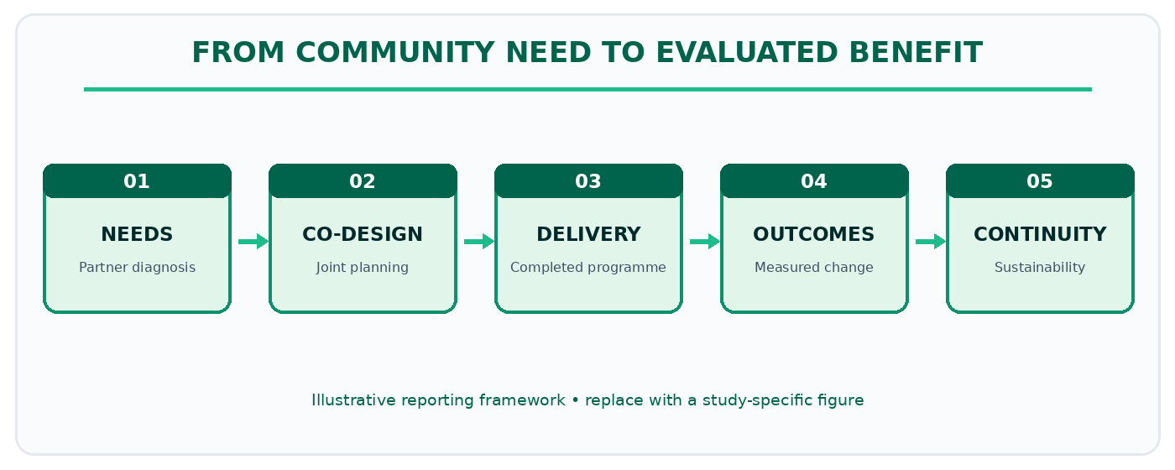
Figure 1. Illustrative reporting pathway for JoCSiS manuscripts. Replace with a study-specific figure.

4. Sustainability and Lessons
Explain why outcomes occurred or failed, how partners responded, what can be transferred, sustainability constraints and what follow-up evidence is still needed.
Explain how the results answer the stated problem, compare with relevant literature and account for alternative explanations or limitations. Interpret evidence without extending conclusions beyond the observed data.

5. Conclusion
Conclude by directly answering the study objective and describing its contribution, limits and implications. Avoid broad claims not supported by the study.
Identify the partners’ role in any continuation of the work, resources needed, and what follow-up evaluation remains necessary. Do not mistake participation totals or satisfaction for long-term community impact.

6. Figures, Tables and Statistical Reporting
Number figures and tables consecutively as cited in the manuscript. Place figure captions below figures and table titles above tables. Supply legible labels, units, definitions, and data provenance. Do not fabricate or cosmetically manipulate findings.
Table 1. Example of a journal-specific evidence summary (replace with actual data).
Community indicator | Baseline status | Observed outcome | Evidence and limitations
[Insert verified data] | [Insert verified data] | [Insert verified data] | [Insert verified data]
[Insert verified data] | [Insert verified data] | [Insert verified data] | [Insert verified data]
[Insert verified data] | [Insert verified data] | [Insert verified data] | [Insert verified data]
Table note. Replace this demonstration with measurements or observations from the submitted study; explain denominators, missing values and interpretation where applicable.

Reference and citation conventions
APA 7; cite evidence for the community need, mechanisms of intervention and appropriate outcome evaluation; evidence quality is more important than an inflexible citation quota.
SUBMISSION CHECK Use the correct article type and section order. Put figures and tables near first mention, and retain editable text in the Word file.

7. Declarations and Ethical Reporting
Document partner authorisation, informed consent where appropriate, photo/voice permissions and protection of vulnerable populations. Do not fabricate impact or identify participants without permission.
Ethics approval: [Name of committee or a reason approval was not applicable; approval number if granted.]
Consent and permissions: [How informed consent and applicable institutional or partner permissions were obtained.]
Funding: [Funder and grant number, or a declaration that no external funding was received.]
Competing interests: [Disclose any competing interests, or state that none are declared.]
Author contributions: [Specify substantive contributions of each author, consistent with journal policy.]
Data and materials availability: [Repository or access conditions; state any ethical, legal or contractual restrictions.]
AI assistance disclosure: [Disclose relevant generative AI assistance and verify all manuscript claims, data and sources.]

8. References
Prepare the reference list in APA 7 format. Every in-text citation must have a matching reference, and each reference must be cited in the text. Do not include fabricated references or unverifiable DOI links.
[Insert references here using a reference manager and validate bibliographic details.]

9. Author Information (Final Accepted Version Only)
[Author name] | [Department and institution, country] | ORCID: [verified ID] | Email: [address]. Remove this information from review copies when anonymous review is required.

10. Pre-Submission Checklist
- The study or completed programme is within this journal’s scope and the article type is accurate.
- The abstract is 150–250 words; the manuscript contains 3–5 precise keywords.
- The methods and results meet the journal-specific evidence standard.
- The figures, tables, citations and references are complete and technically legible.
- Permissions, ethics, funding, contributions, data access and relevant AI disclosures are reported.

