
• GIA PRESS • 2026
  JOURNAL IDENTITY  Journal of Intelligent Pedagogy  GIA Press | joip.giapress.com  PUBLICATION METADATA  Volume: [XX] Issue: [X]  DOI: [add assigned article DOI]  Received: [day month year]  Revised: [day month year]  Accepted: [day month year]  ARTICLE CATEGORY  ☐ Empirical Research Article  ☐ Design-Based Research  ☐ Human–AI Learning Evaluation  ☐ Validated Educational Technology Study  REPORTING PRIORITY  Explain the pedagogical problem, the AI or EdTech intervention and evidence of meaningful educational outcomes.  EDITORIAL NOTE  Replace bracketed fields and all instructions before submitting. Journal identifiers are placeholders until verified. | MANUSCRIPT TITLE  [Insert a precise, searchable article title identifying the study, intervention and context]  Article type: [select a category from the journal list]  ABSTRACT  Write a self-contained abstract of 150–250 words. Pedagogical problem; technology/model and study population; comparison/evaluation methods; actual educational findings; limitations and implications.  KEYWORDS  [keyword 1]; [keyword 2]; [keyword 3]; [keyword 4]; [keyword 5]  SCOPE AND CONTRIBUTION  Evaluate a meaningful pedagogical question involving AI/EdTech; technical system performance alone does not establish learning effectiveness.  FORMATTING AT A GLANCE  • Language: English; editable Word manuscript (.docx).  • Suggested length: approximately 4,000–7,000 words; APA 7 references.  • Title and manuscript must describe what was actually investigated or implemented.

1. Introduction and Related Literature
Begin with a pedagogical problem rather than a description of an AI product. Compare related studies and alternative approaches, then identify the outcome that the proposed system or intervention will test.
Evaluate a meaningful pedagogical question involving AI/EdTech; technical system performance alone does not establish learning effectiveness.
WHAT BELONGS HERE Identify the educational technology, learning activity and outcome/evaluation setting; distinguish development from effectiveness.

2. Research Methods and Technology Design
Describe the learning context and the AI or educational technology sufficiently for replication or informed comparison. Report system configuration and data sources alongside learners, instruments, validity evidence and safeguards.
AI system/version or platform; educational task; learner population; datasets; comparison or baseline; measures of learning and usability; ethical safeguards; analysis.

Designs appropriate to this journal
Experimental and quasi-experimental evaluations, design-based research, learning-analytics studies, human-AI interaction studies, validated usability plus learning-outcome investigations, systematic reviews.

Minimum methodological documentation
- AI model, platform or technology version and educational context
- Comparison condition, learning measures, user groups and data analysis
- Privacy, bias, human oversight and reproducible evaluation

3. Results
Report both technical performance and pedagogy-relevant outcomes; distinguish perceived usefulness, usability and measured learning gains; report bias/failure cases.
EVIDENCE STANDARD Pedagogical problem, transparent technology/model description, fair comparison or meaningful baseline, valid learning measures, risk/ethics assessment, reproducible evaluation.

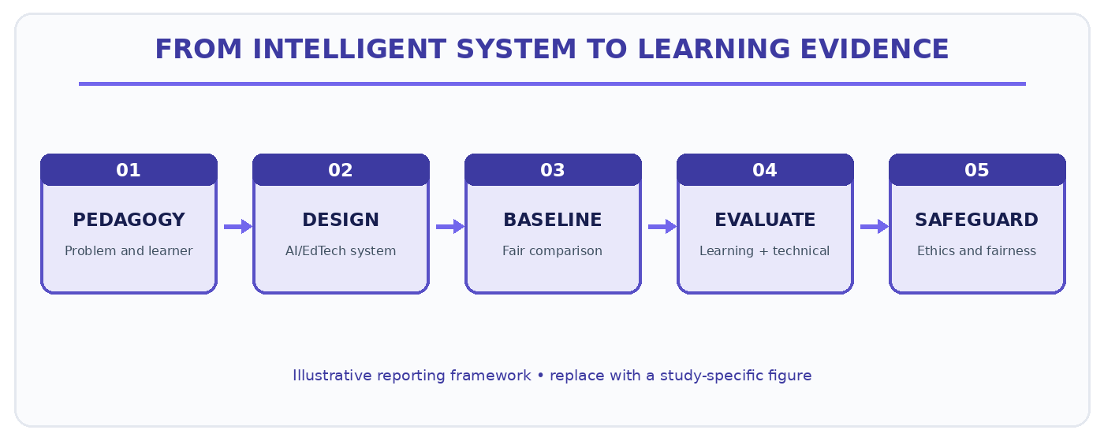
Figure 1. Illustrative reporting pathway for JoIP manuscripts. Replace with a study-specific figure.

4. Discussion and Responsible-AI Limitations
Explain how design features relate to learning theory, human decision-making, inclusion, fairness, privacy and limitations; compare with alternatives.
Explain how the results answer the stated problem, compare with relevant literature and account for alternative explanations or limitations. Interpret evidence without extending conclusions beyond the observed data.

5. Conclusion
Conclude by directly answering the study objective and describing its contribution, limits and implications. Avoid broad claims not supported by the study.
Distinguish technical model performance from learners’ educational outcomes and state the limits of AI-based inference, generalisability and responsible use.

6. Figures, Tables and Statistical Reporting
Number figures and tables consecutively as cited in the manuscript. Place figure captions below figures and table titles above tables. Supply legible labels, units, definitions, and data provenance. Do not fabricate or cosmetically manipulate findings.
Table 1. Example of a journal-specific evidence summary (replace with actual data).
Educational measure | Comparison group | Learning result | Technical / ethical note
[Insert verified data] | [Insert verified data] | [Insert verified data] | [Insert verified data]
[Insert verified data] | [Insert verified data] | [Insert verified data] | [Insert verified data]
[Insert verified data] | [Insert verified data] | [Insert verified data] | [Insert verified data]
Table note. Replace this demonstration with measurements or observations from the submitted study; explain denominators, missing values and interpretation where applicable.

Reference and citation conventions
APA 7; include relevant current AI-in-education studies, comparable baselines, ethics/privacy and learning-science research.
SUBMISSION CHECK Use the correct article type and section order. Put figures and tables near first mention, and retain editable text in the Word file.

7. Declarations and Ethical Reporting
Declare source and permissions for datasets, platforms, learner data, AI versions and human oversight; address bias, confidentiality and security.
Ethics approval: [Name of committee or a reason approval was not applicable; approval number if granted.]
Consent and permissions: [How informed consent and applicable institutional or partner permissions were obtained.]
Funding: [Funder and grant number, or a declaration that no external funding was received.]
Competing interests: [Disclose any competing interests, or state that none are declared.]
Author contributions: [Specify substantive contributions of each author, consistent with journal policy.]
Data and materials availability: [Repository or access conditions; state any ethical, legal or contractual restrictions.]
AI assistance disclosure: [Disclose relevant generative AI assistance and verify all manuscript claims, data and sources.]

8. References
Prepare the reference list in APA 7 format. Every in-text citation must have a matching reference, and each reference must be cited in the text. Do not include fabricated references or unverifiable DOI links.
[Insert references here using a reference manager and validate bibliographic details.]

9. Author Information (Final Accepted Version Only)
[Author name] | [Department and institution, country] | ORCID: [verified ID] | Email: [address]. Remove this information from review copies when anonymous review is required.

10. Pre-Submission Checklist
- The study or completed programme is within this journal’s scope and the article type is accurate.
- The abstract is 150–250 words; the manuscript contains 3–5 precise keywords.
- The methods and results meet the journal-specific evidence standard.
- The figures, tables, citations and references are complete and technically legible.
- Permissions, ethics, funding, contributions, data access and relevant AI disclosures are reported.

